Log Data with NodeMCU and Google Sheets

Most of the time, the data from a sensor in an IoT application needs to be recorded. This data logging is important for later statistical analysis now most popularly known as data analytics. In this tutorial, we will record the data captured from the sensor to a spreadsheet. Let's build a NodeMCU Google Sheets data logger!

We will be using the same circuit we used in the last tutorial. The new things we need for this tutorial are

* [Pushingbox](https://www.pushingbox.com/) account
* [Google Drive](http://drive.google.com/) account

Pushingbox is an API that will help capture data from the NodeMCU to the Google Sheet. It is necessary because Google does not allow direct logging via HTTP ever since its move to HTTPS.

**Contents**[[show](https://www.teachmemicro.com/log-data-nodemcu-google-sheets/)]

Step 1: Create a Blank Spreadsheet]

Log-in to your Google Drive account. Create a blank spreadsheet and name it.

Step 2: Create a Form

Next, create a new form. Place a "short answer text" as an input field.  Then on the upper right corner, click the preview button. This will open a new window.

[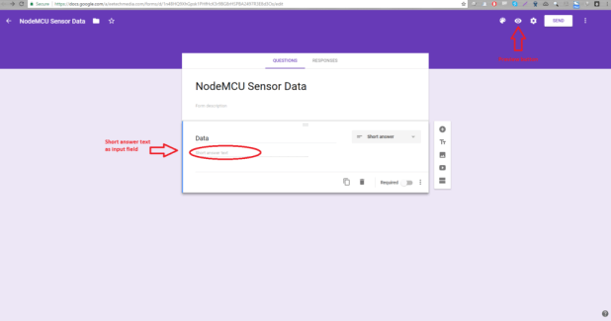](https://i1.wp.com/www.teachmemicro.com/wp-content/uploads/2017/05/nodemcu-google-sheet-1.png?ssl=1)*click to view larger image*

Get the URL of the newly opened window. For example, mine's: *https://docs.google.com/forms/d/e/1FAIpQLScKRqbOYnFFCG9vyyWqPQiwuviTqiUrmvI5BfNZcwGq2A2OSA/viewform*. Then right-click on the input field you just created and choose "Inspect". On the "Elements" tab, you will acquire the name of the input field. Mine's *entry.495151502* as pictured. We need this for later.

[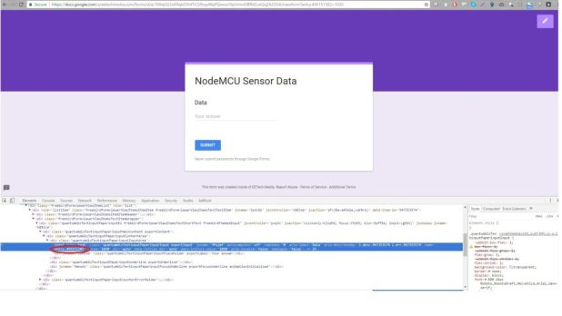](https://i1.wp.com/www.teachmemicro.com/wp-content/uploads/2017/05/nodemcu-google-sheet-5.jpg?ssl=1)

Step 3: Link the Form to the Spreadsheet

Go back to the previous window (where you edit the form) and click the "Responses" tab. You'll see the Google Sheet icon just above the "Accepting Responses" switch.  Click it and a window will pop out. Choose "Select existing spreadsheet" and click "Select". Choose the spreadsheet you created in Step 1.

[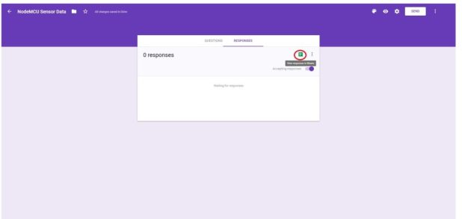](https://i1.wp.com/www.teachmemicro.com/wp-content/uploads/2017/05/nodemcu-google-sheet-6.jpg?ssl=1)

Step 4: Configure Pushingbox

Now go to pushingbox.com and create an account using the same email you used for Google drive. Click the "My Services" tab and click the "Add a service" button. Select "CustomURL". Fill in the form that popped out. Name the service  then on the Root URL field, paste the Google Form URL **BUT** replace "viewform" with "formResponse". Example, using the url above, that would be *https://docs.google.com/forms/d/e/1FAIpQLScKRqbOYnFFCG9vyyWqPQiwuviTqiUrmvI5BfNZcwGq2A2OSA/formResponse*. Leave the Method field as GET.

[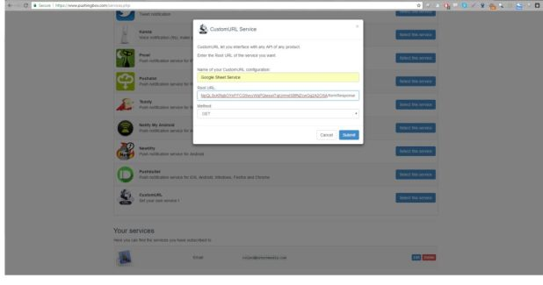](https://i2.wp.com/www.teachmemicro.com/wp-content/uploads/2017/05/nodemcu-google-sheet-3.jpg?ssl=1)

Next, go to "My Scenarios". On the text field, give a name for the scenario and click "Add". Then click "Add an Action". Click the "Add an action with this service" of the service you just created. On the field on the window that pops out, type in the name of the input field in the form plus the "=$data$". You will be given a device ID after that.

[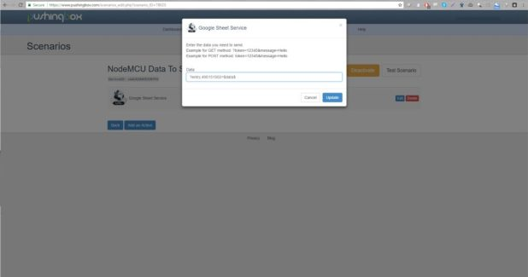](https://i0.wp.com/www.teachmemicro.com/wp-content/uploads/2017/05/nodemcu-google-sheet-4.jpg?ssl=1)

Step 5: Write the NodeMCU Code

After getting the device ID, its time to write a code for the NodeMCU. Here's mine: